Alejandro Ceballos

10-12-2025

CS500-1

Module 1 Critical Thinking Assignment

# Pseudocode for Assignment 1

**// Part 1: Addition and Subtraction //**

PROGRAM START

get user input for num1

get user input for num2

variable addition = num1 + num2

variable subtraction = num1 - num2

display addition result

display subtraction result

END PROGRAM

**// Part 2: Multiplication and Division //**

PROGRAM START

get user input for num1

get user input for num2

variable multiplication = num1 * num2

IF num2 is not zero THEN

variable division = num1 / num2

display division result

ELSE

display error message for division by zero

END PROGRAM

# Source Code for Assignment 1

# Author: Alejandro Ceballos

# Date: 2025-10-12

# Assignment 1: Creating Python Programs

# Part 1:

# Write a Python program to find the addition and subtraction of two numbers.

# Ask the user to input two numbers (num1 and num2). Given those two numbers, add them together to find the output. Also, subtract the two numbers to find the output.

# Part 2:

# Write a Python program to find the multiplication and division of two numbers.

# Ask the user to input two numbers (num1 and num2). Given those two numbers, multiply them together to find the output. Also, divide num1/num2 to find the output.

# // Part 1: Addition and Subtraction //

# Get user input

print("// Part 1 Addition and Subtraction //")

num1 = float(input("Enter your first number: "))

num2 = float(input("Enter your second number: "))

# add both numbers

addition = num1 + num2

# subtract both numbers

subtraction = num1 - num2

# Display results to the user

print(f"The addition of {num1} and {num2} is: {addition}")

print(f"The subtraction of {num1} and {num2} is: {subtraction}", end="\n\n")

# // Part 2: Multiplication and Division //

# Get user input

print("// Part 2 Multiplication and Division //")

num1 = float(input("Enter your first number: "))

num2 = float(input("Enter your second number: "))

# multiply both numbers

multiplication = num1 * num2

# Display results to the user

print(f"The multiplication of {num1} and {num2} is: {multiplication}")

# Perform division with error handling for division by zero

if num2 != 0:

division = num1 / num2

print(f"The division of {num1} by {num2} is: {division}")

else:

print("Error: Cannot divide a number by zero.")

# Output

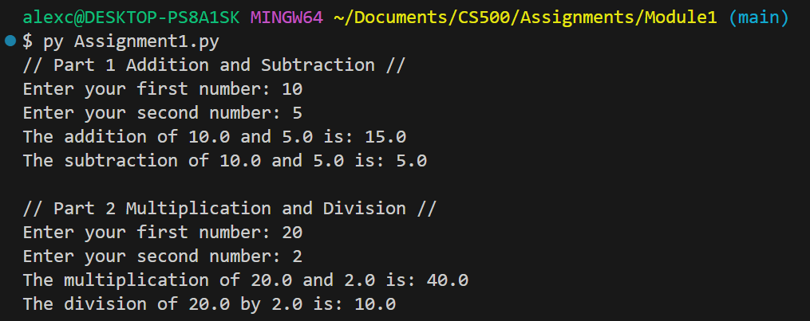

GIT REPO LINK: [GIT REPOSITORY](https://github.com/AlejandroBrick/CS500)